Project Report Format

# INTRODUCTION

* 1. **ProjectOverview**

Hematovision is an AI-powered diagnostic project aimed at enhancing the accuracy and efficiency of blood cell classification through advanced deep learning techniques. Manual examination of blood smears is time-consuming, prone to human error, and requires expert pathologists. The aim of Hematovision is to design, develop, and deploy a deep learning-based model that can automatically classify blood cells from microscope images using transfer learning techniques. This tool is intended to assist medical professionals in diagnosis, reduce human error, and make hematological analysis faster and more consistent.

Hematovision leverages transfer learning with pre-trained convolutional neural networks (CNNs) to automate and improve the classification of blood cells in microscopic images.

* 1. **Purpose**

The primary purpose of Hematovision is to **automate and enhance the accuracy of blood cell classification** using deep learning, specifically transfer learning, in order to assist medical professionals in faster and more reliable diagnosis of hematological disorders.

Manual examination of blood smear slides is time-consuming, labor-intensive, and prone to human error. By applying advanced machine learning techniques, Hematovision aims to:

* **Reduce diagnostic time** an
* d improve clinical workflow.
* **Enhance accuracy** in identifying various blood cell types, including abnormal or diseased cells.
* **Support early detection** of critical conditions like anemia, leukemia, and infections.
* **Make diagnostic tools more accessible**, especially in resource-limited or remote healthcare settings.

Ultimately, Hematovision seeks to **bridge the gap between AI technology and clinical hematology**, enabling smarter, faster, and more consistent blood analysis.

**2. IDEATION PHASE**

2.1 Problem Statement

2.2 Empathy Map Canvas

2.3 Brainstorming

**3. REQUIREMENT ANALYSIS**

3.1 Customer Journey map

3.2 Solution Requirement

3.3 Data Flow Diagram

3.4 Technology Stack

**4. PROJECT DESIGN**

4.1 Problem Solution Fit

4.2 Proposed Solution

4.3 Solution Architecture

**5. PROJECT PLANNING & SCHEDULING**

5.1 Project Planning

**6. FUNCTIONAL AND PERFORMANCE TESTING**

6.1 Performance Testing

# 7.RESULTS

**Output Screenshots**

The complete execution of the **HematoVision** application is shown step-by-step in the screenshots below.

**Step 1: Run the app.py script**

Once the script is run, the terminal displays a link to access the web app locally at http://127.0.0.1:5000.

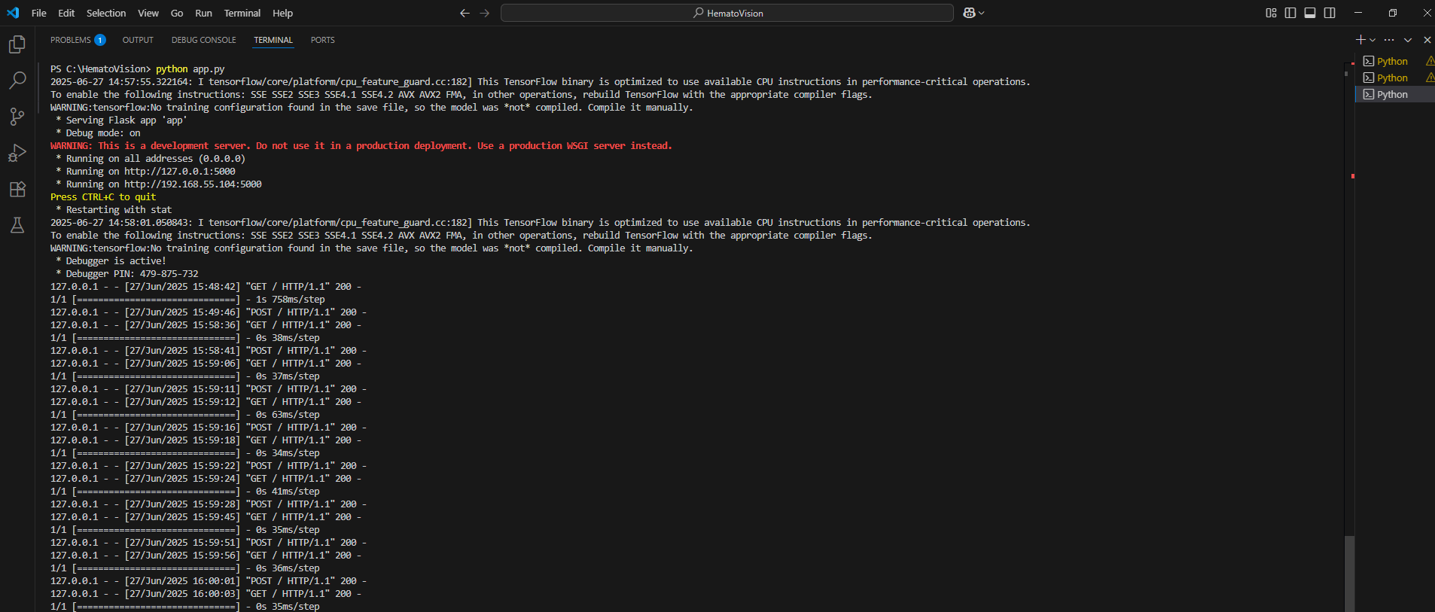

**Fig 7.1.1: Code running in Terminal**

#### Step 2: **Access the Web Interface**

Clicking the local server link opens the HematoVision homepage in a browser.

.

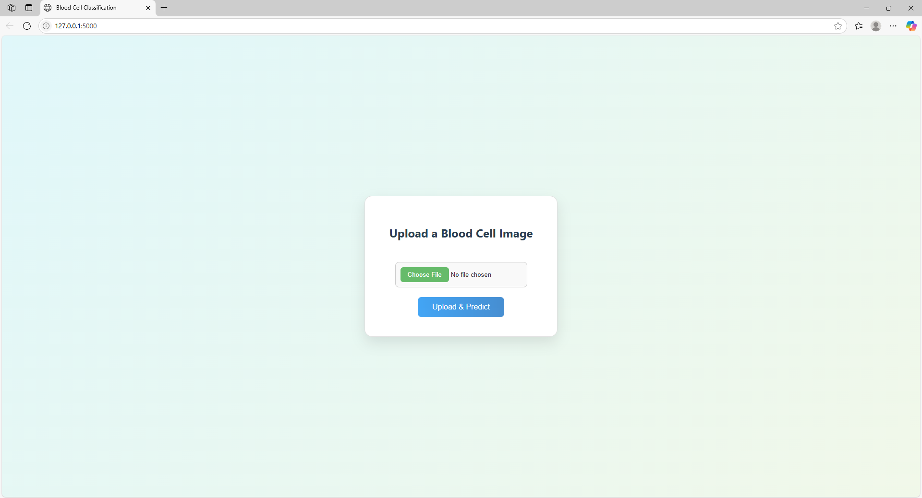

**Fig 7.1.2:** HematoVision Home Page

#### Step 3: **Upload Image**

Click “Choose File” to upload a blood cell image from your computer.

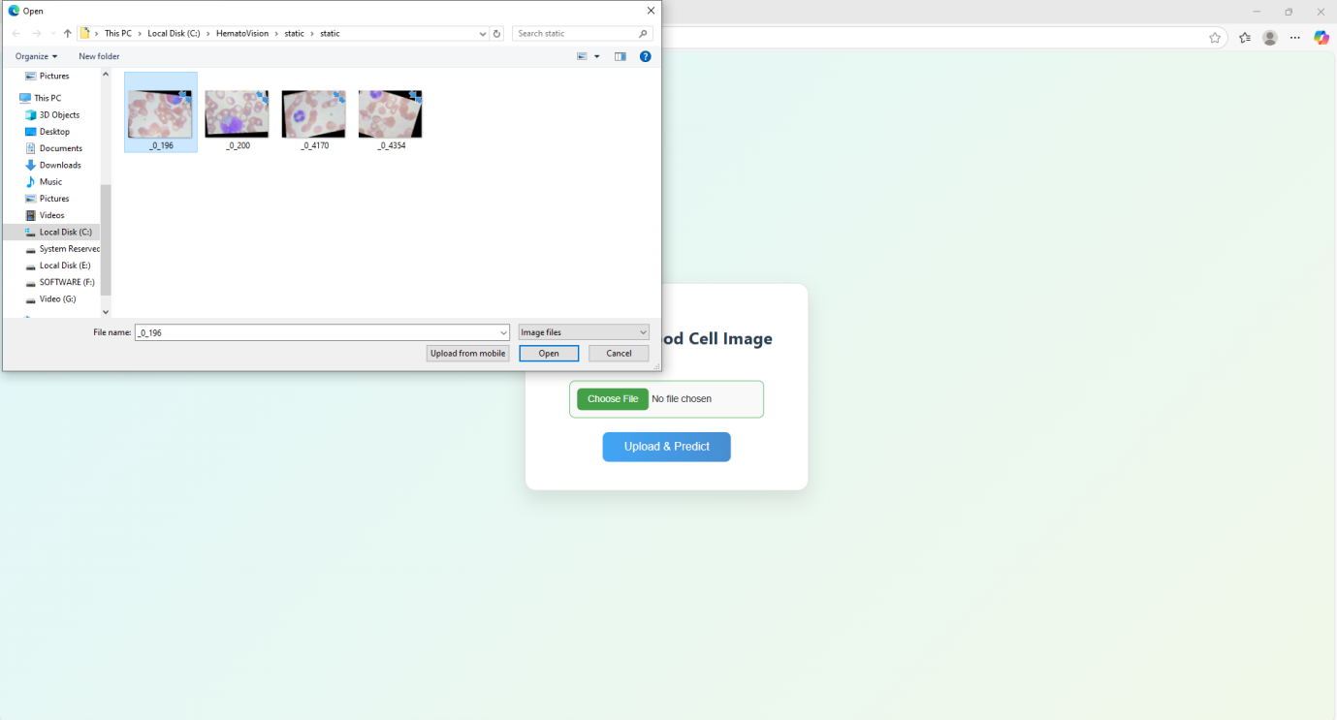

**Fig 7.1.3:** File upload page

#### Step 4: **Click “Predict”**

After selecting an image, click the **Predict** button to classify the cell type.

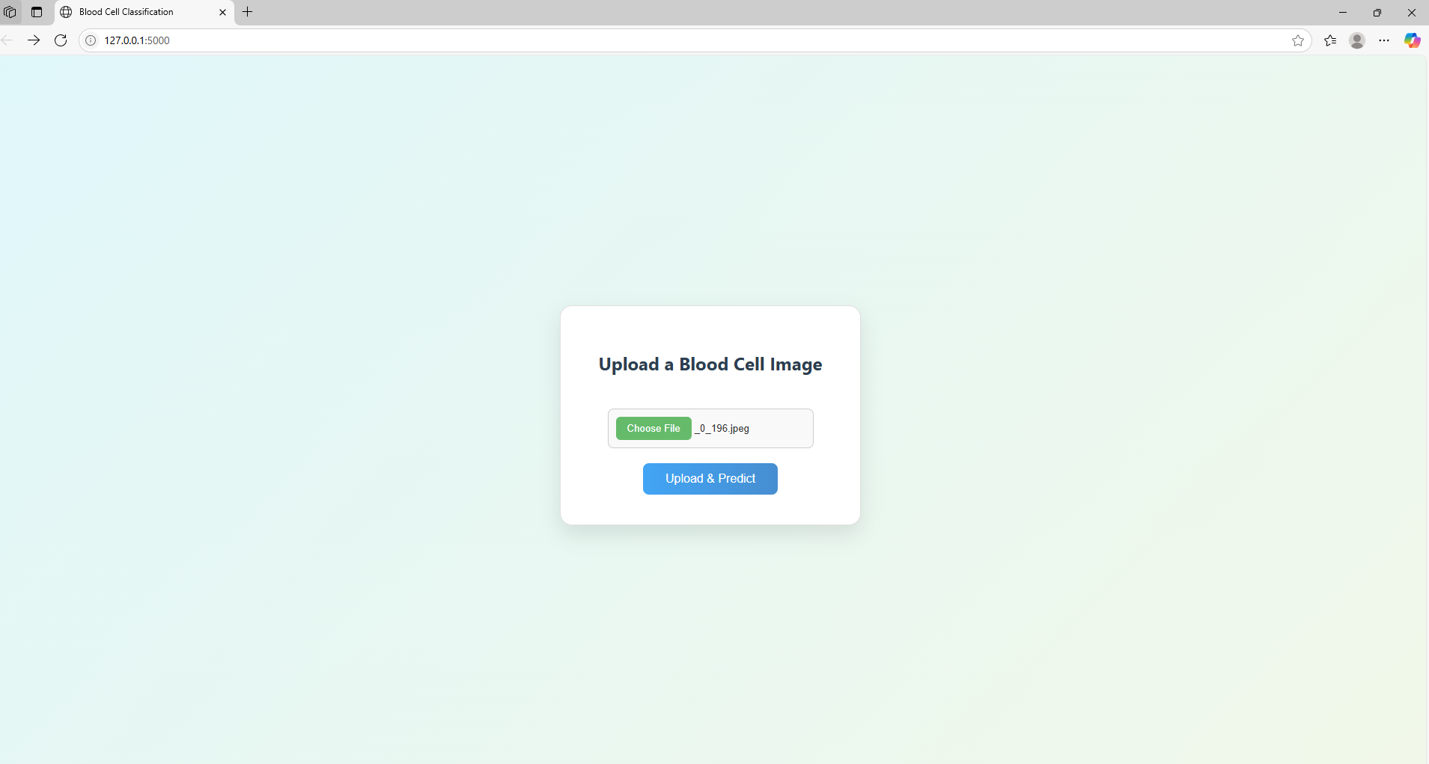

**Fig 7.1.4:** Selected image displayed on prediction page

#### Step 5: **View Prediction Results**

The application will display the uploaded image and the predicted cell type.

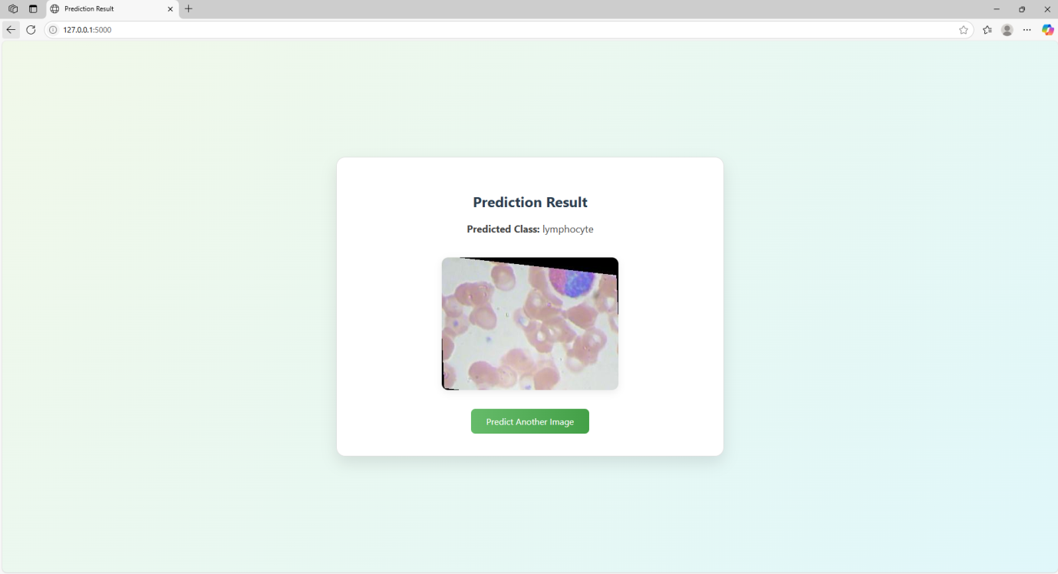

**Fig 7.1.5:** Prediction result with image preview

**Step 6:** After clicking the **Predict** button, the model processes the uploaded image and classifies the type of white blood cell (e.g., Lymphocyte, Neutrophil, etc.).  
Below are some example outputs from real test images, showcasing accurate predictions and model confidence..

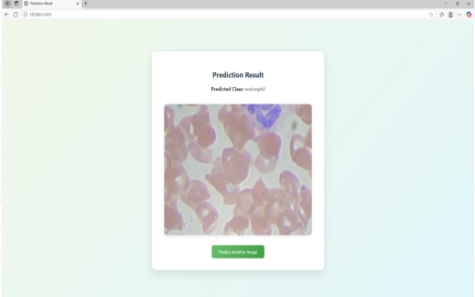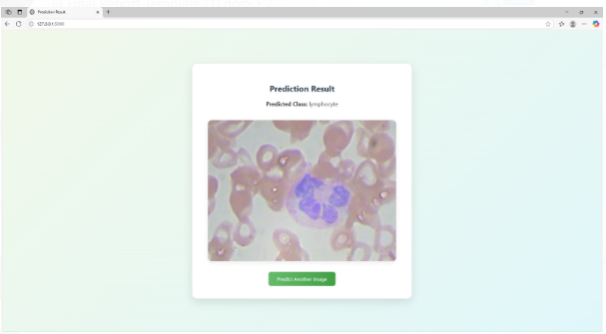 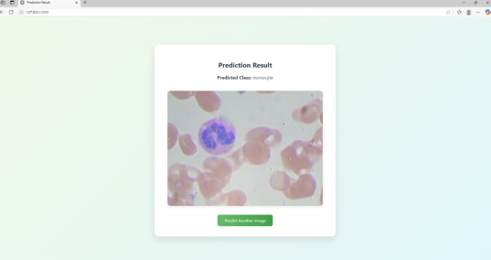 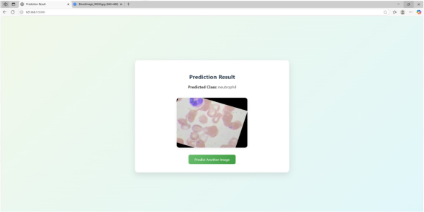

**Fig 7.1.6: Prediction output for various test inputs with high accuracyAfter the Images**

All uploaded images are stored in the static/uploads/ directory for reference or reuse.

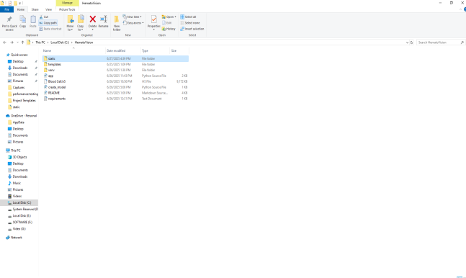 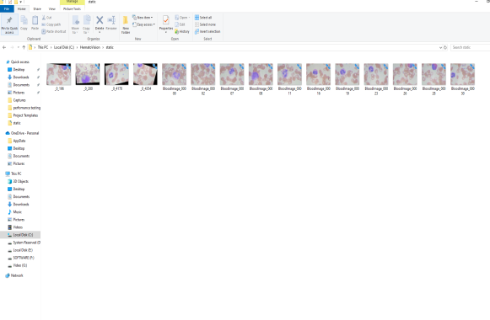

**Fig 7.1.7: Folder structure showing stored uploaded images**

### **Step 1: Running the Flask Application**

* Run the **app.py**file from your terminal or VS Code.
* You will see the Flask server starting message.
* The application will be accessible at:
  + [**http://127.0.0.1:5000**](http://127.0.0.1:5000)

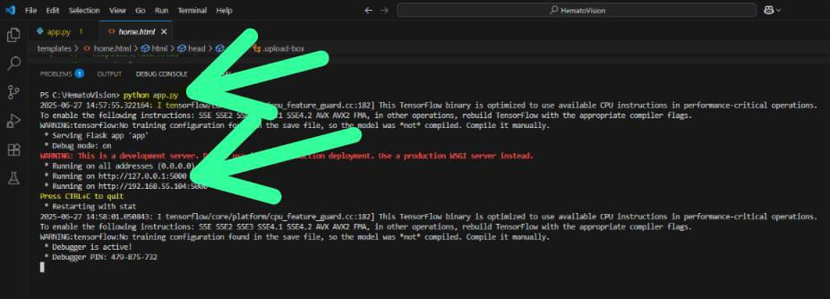

**Step 2: Open your terminal/command prompt**

* On Windows: Press Windows + R, type cmd, and press Enter.
* On macOS/Linux: Open Terminal

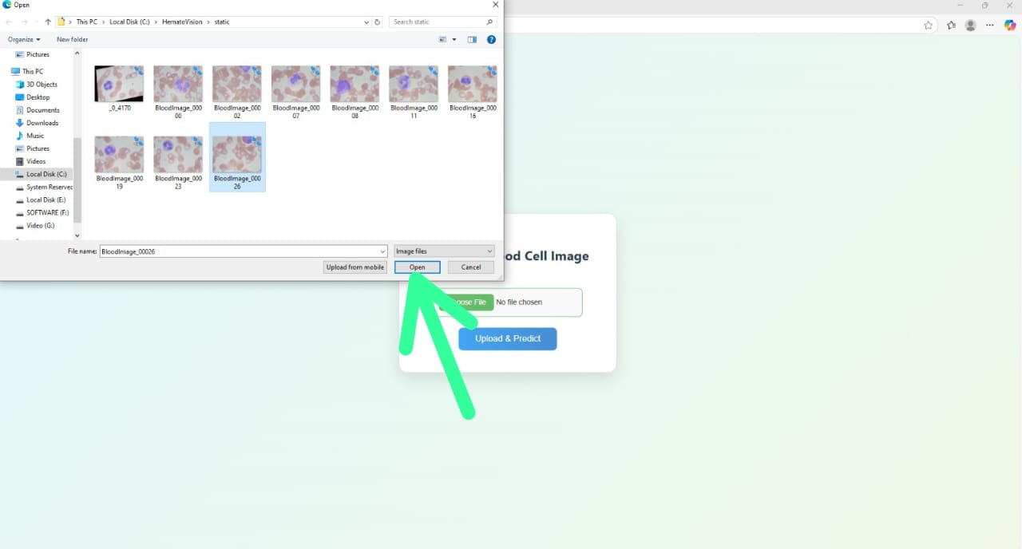

**Step 3 :**Look for a file named something like:

* + start.bat or run.bat (Windows)
  + start.sh (Linux/macOS)
  + Or a shortcut called **"Start Hematovision**

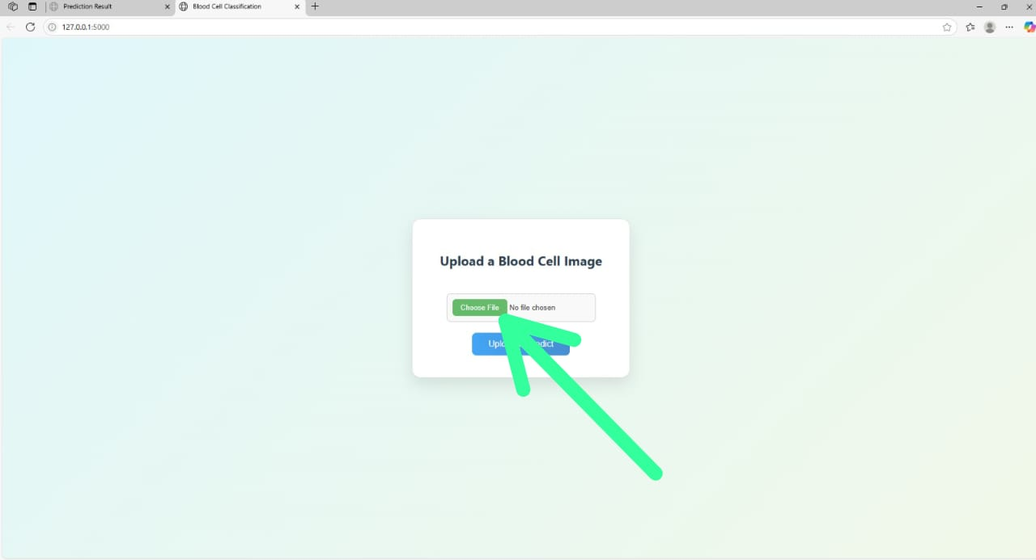

**Step 4 :Start Using the Application**

* The Hematovision interface will appear in the browser.
* You can now:
  + Upload blood smear images.
  + View classification results.
  + Interact with the application as needed

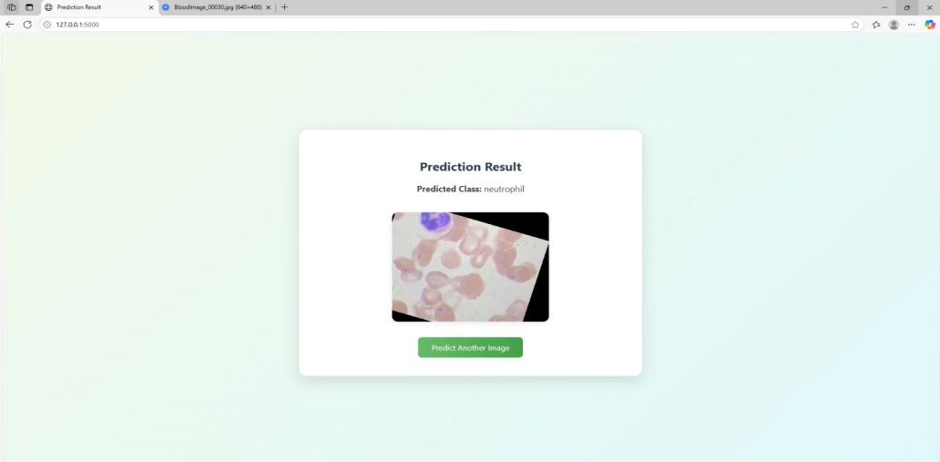

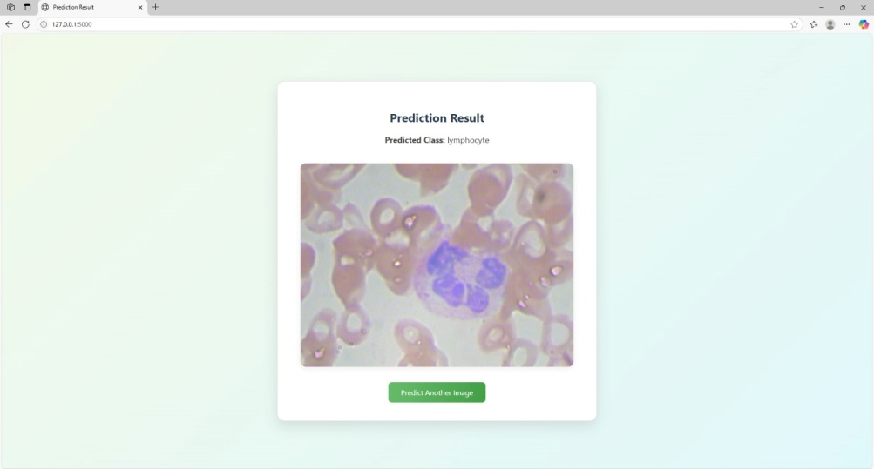

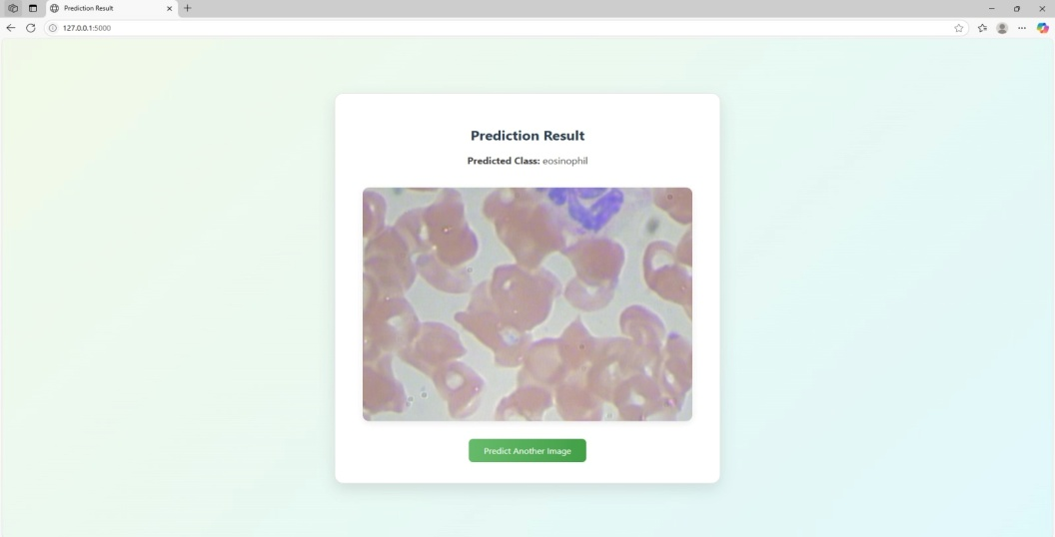

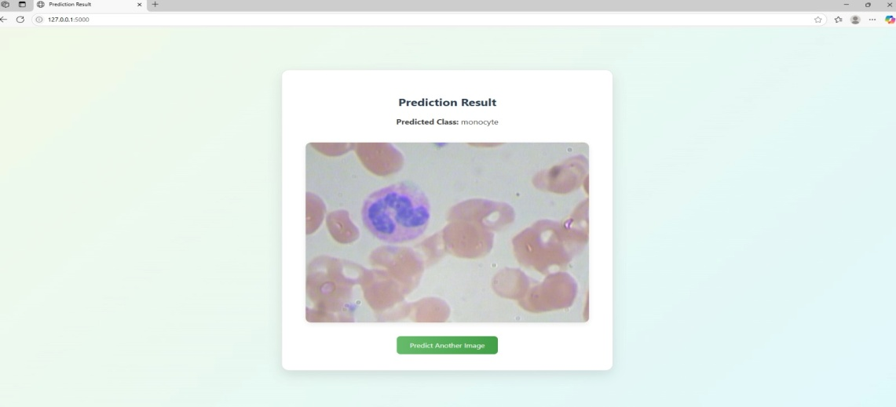

**8.ADVANTAGES&DISADVANTAGES**

**ADVANTAGES:**

1. Improved Accuracy

* Uses deep learning models trained on large datasets to classify blood cells with high precision.
* Reduces human error that may occur due to fatigue or inexperience**.**

2. Faster Diagnosis

* Provides real-time or near-instant classification of blood cells.
* Helps speed up the diagnostic process in emergency and high-volume clinical settings.

3. Supports Early Disease Detection

* Can detect abnormal cells (e.g., blast cells in leukemia, malaria parasites) early.
* Supports timely medical intervention and better patient outcomes.

4. Cost-Effective and Scalable

* Reduces the need for expensive diagnostic equipment and repeated lab tests.
* Can be deployed in clinics, labs, and even remote or resource-limited areas.

5. Uses Transfer Learning for Efficiency

* Leverages pre-trained models, which means less training data is needed.
* Saves development time and computing resources.

**DISADVANTAGES:**

1. Dependence on Quality Data

* The model’s performance highly depends on high-resolution, accurately labeled images.
* Poor image quality (blurred, improperly stained) can lead to misclassification.

**2**. Limited by Dataset Diversity

* If the dataset used for training lacks diverse samples (e.g., rare cell types or patient variations), the model may perform poorly in real-world clinical scenarios.

**3.** Lack of Explainability

* Deep learning models often work as “black boxes” and may not explain why a particular prediction was made.
* This reduces trust and limits adoption by medical professionals.

**9.CONCLUSION**

Hematovision represents a significant step forward in the field of automated medical diagnostics by harnessing the power of transfer learning and deep learning for blood cell classification. The project demonstrates how advanced AI techniques can reduce the dependency on manual microscopic analysis, offering faster, more accurate, and consistent results. By automating the classification process, Hematovision not only improves diagnostic efficiency but also supports early detection of life-threatening conditions such as leukemia, anemia, and infections.Despite some limitations—such as dependency on high-quality data, need for expert oversight, and infrastructure requirements—the system offers **substantial benefits** in clinical and research settings.

1. **FUTURESCOPE**

The future scope of Hematovision is vast and promising, with the potential to revolutionize hematological diagnostics. As the system evolves, it can be expanded to classify a broader range of blood cell types and detect additional disorders such as malaria, sickle cell anemia, and various blood cancers. Integration with electronic health records (EHR) and laboratory information systems could enable real-time reporting and improved clinical workflow. Furthermore, optimizing the model for mobile and edge devices would make it accessible in remote or under-resourced areas. Future developments may also include real-time analysis through integration with digital microscopes, offering immediate diagnostic insights during sample examination. Incorporating explainable AI features can enhance transparency and trust among medical professionals by visualizing decision-making processes

**10. APPENDIX**

**Source Code:**

All codes are submitted in Git-Hub Repository.

**Git-Hub Repository Link:**

**Dataset Link:** **Link:** [**https://www.kaggle.com/datasets/paultimothymooney/blood-cells/data**](https://www.kaggle.com/datasets/paultimothymooney/blood-cells/data)

**Project Demo Link:** <https://drive.google.com/file/d/1jkXonfIR4F6SJooRcLCZzL83cJE3ErhH/view?usp=drivesdk>